**Create table Employee(Emp id, emp name, empdesignation, emplevel,emp address)**

**Insert 10 records**

**Execute all queries (alter, update, delete,drop,modify,rename table,rename column etc)**

**Take screenshot of the screen and Put in the word document .**

1. **Show databases**

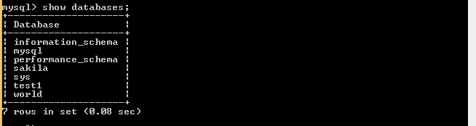

1. **Create database;**



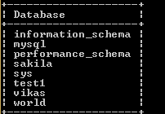

1. **Use database name ;**



1. **Create table employee**



1. **Show table**

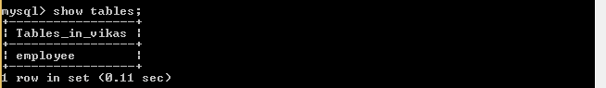

1. **Insert into employee**



**With data 10 employee process is recurring**

1. **Select* from table**

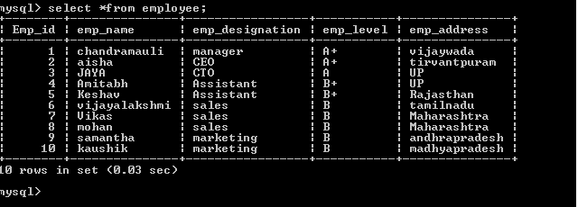

1. **Rename table**



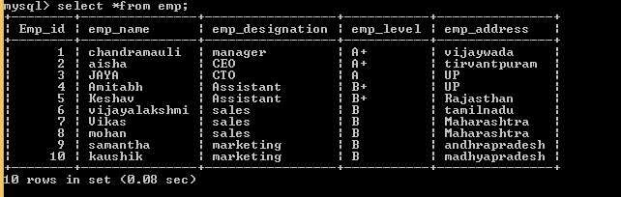

1. **Rename column**

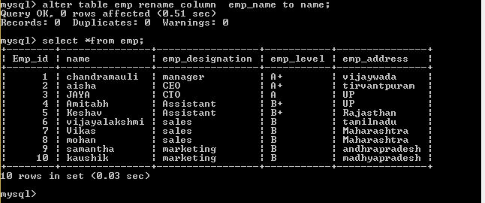

**10 adding a column**

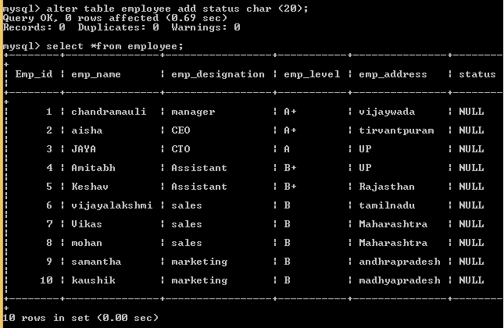

**11Updating column**

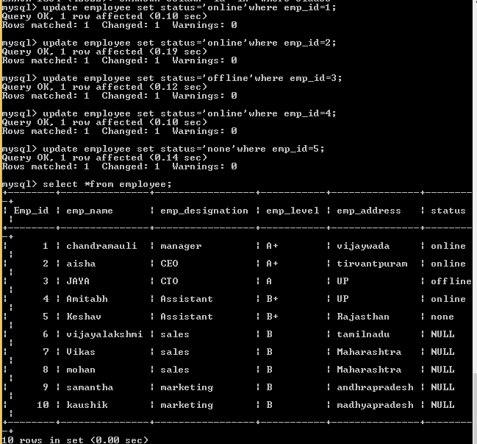

**12.Drop column**

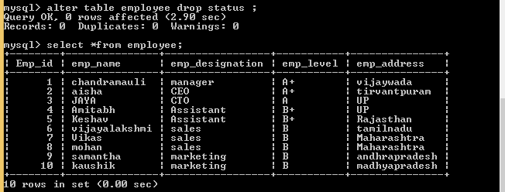

**13. delete row from table**

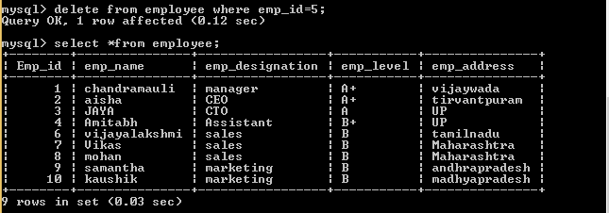

**14 modify**

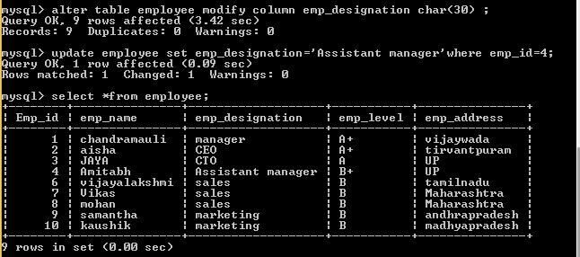

**14 set autocommit=0;**



**15. savepoint save point name;**

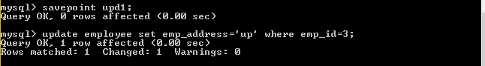

**16 Roll Back to savepoint name;**

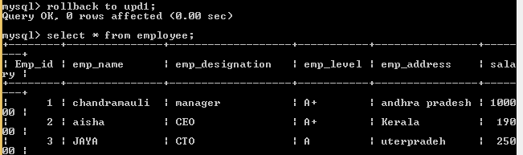

**17. commit**

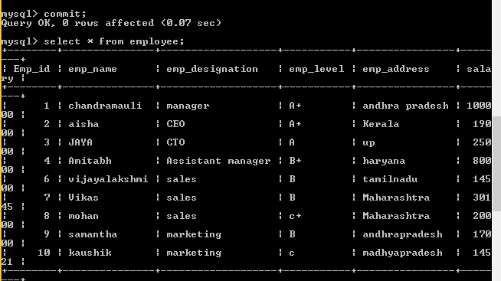

**18.** **Filtering on a single condition**

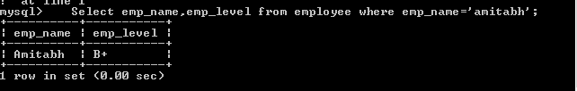

**19. Filtering on a single value**

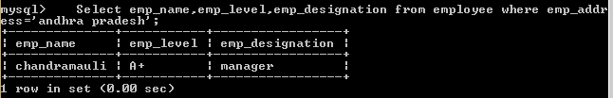

**20 Filtering with a range of values:**

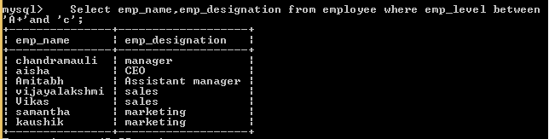

**21. IN operator**

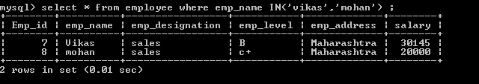

**22. OR Operator**

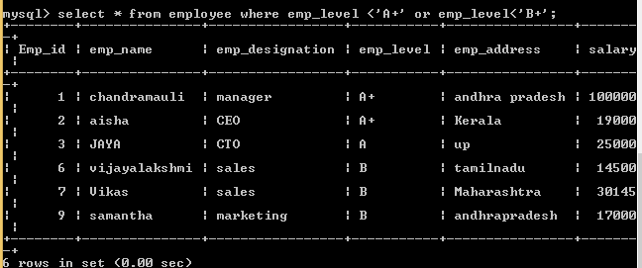

**23. AND Operator**

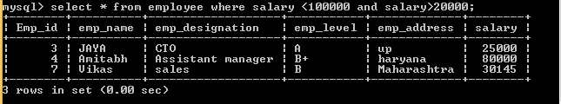

**24. NOT Operator**

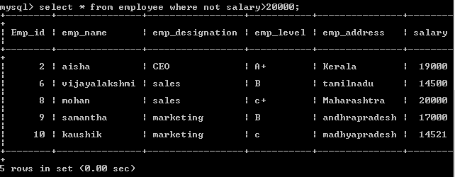

**25. LIKE Operator**

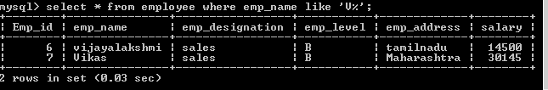

**26 ORDER BY**

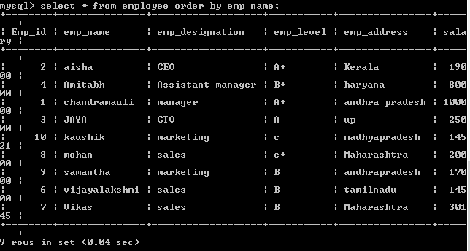

**27.** **GROUP BY**

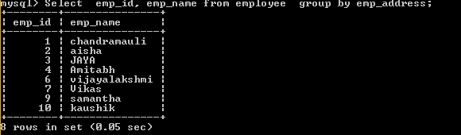

**28. COUNT:**

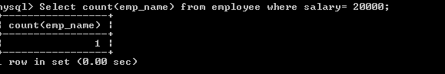

**29.Avg**

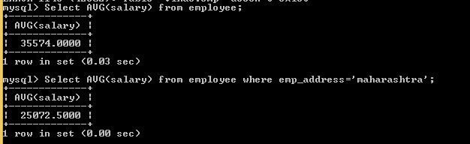

**30 SUM**

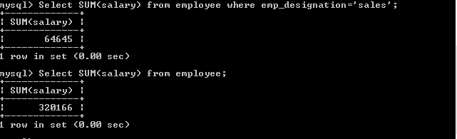

**31. max**

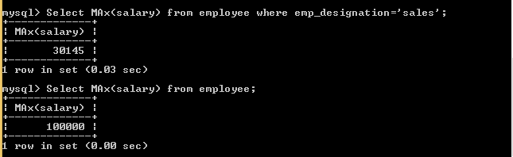

**32. Min**

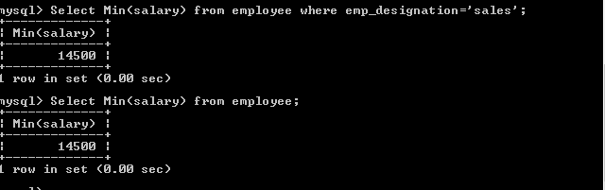

**33. Wildcard operators**

**Like operator**

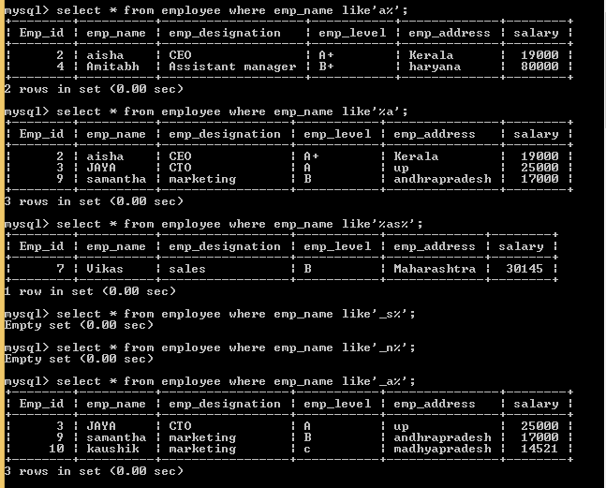

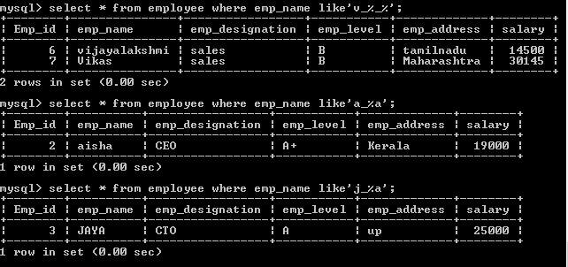

**34 subqueries**

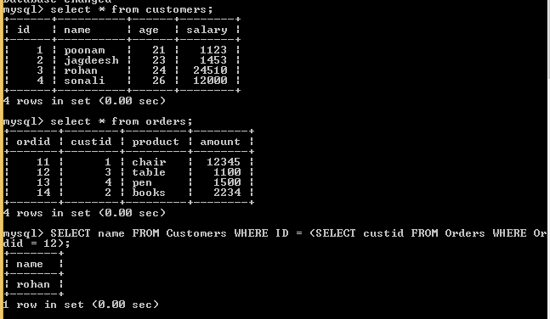

**35 joins**

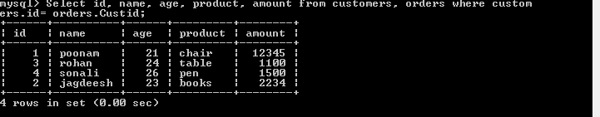

**36. inner join**

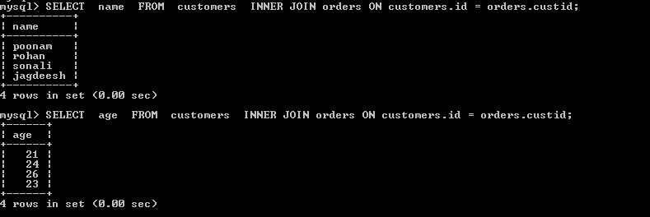

**37. left join**

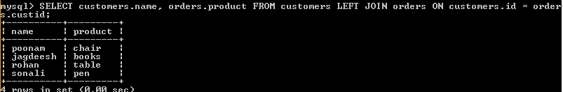

**38.Right joins**



**39 Full Join**

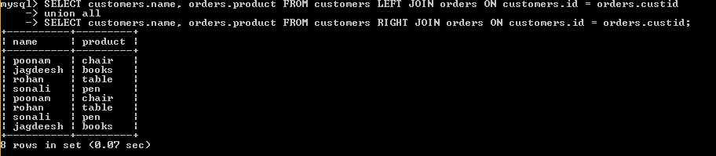

**40. self join**

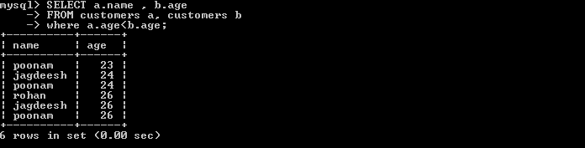

**41. Cartesian join**

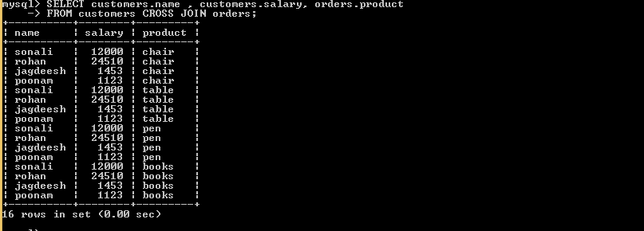

**42. alias name**

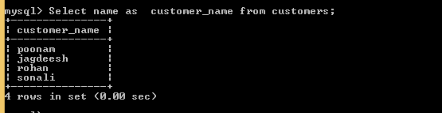

**43. concat**

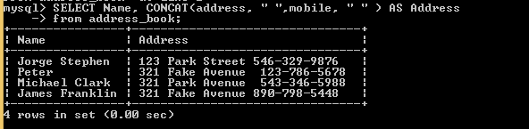

**44 Trim**

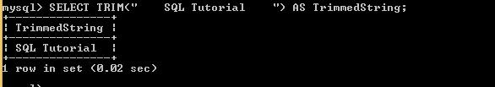

**45. current timestamp**

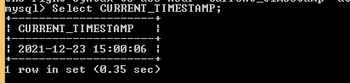

**46.date add**



**47.** **DATEDIFF**

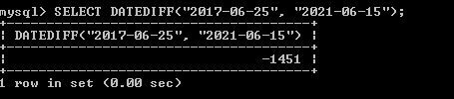

**48 date from part**

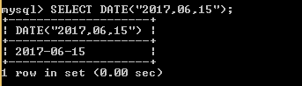

**49 day**



**50 month**

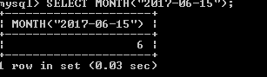

**51. year**



**52 case statement**

